|  |  |  |
| --- | --- | --- |
| /’;’; | **LIFE SAVER -**  **A BLOOD DONOR APPLICATION** |  |

## A MINI PROJECT REPORT

***Submitted by***

|  |  |
| --- | --- |
| **AGASH A** | **(720721104063)** |
| **DHANASELVAN J U** | **(720721104076)** |
| **JASWANTH K** | **(720721104094)** |
|  |  |

***in partial fulfillment for the award of the degree of***

# BACHELOR OF ENGINEERING

***in***

**COMPUTER SCIENCE AND ENGINEERING**

# Hindusthan College of Engineering and Technology

Approved by AICTE, New Delhi, Accredited with ‘A++’ Grade by NAAC **(An Autonomous Institution, Affiliated to Anna University, Chennai)** Valley Campus, Pollachi Highway, Coimbatore – 641 032

**NOV 2023**

|  |  |  |
| --- | --- | --- |
|  | **Hindusthan College of Engineering and Technology**  Approved by AICTE, New Delhi, Accredited with ‘A++’ Grade by NAAC **(An Autonomous Institution, Affiliated to Anna University, Chennai)** Valley Campus, Pollachi Highway, Coimbatore – 641 032 |  |

# BONAFIDE CERTIFICATE

Certified that this project report **“LIFE SAVER - BLOOD DONOR APPLICATION”** is the bonafide work of **“AGASH. A (720721104063), DHANASELVAN J U (720721104076), JASWANTH. K (720721104094)”** who carried out the project work under my supervision.

|  |  |
| --- | --- |
| **SIGNATURE**  **MR.M. PRIYADHARSHAN, M.E, (Ph.D.)**  **SUPERVISOR**  Assistant Professor  Computer Science and Engineering,  Hindusthan College of Engineering and Technology, Coimbatore-32 | **SIGNATURE**  **Dr. S. SHANKAR, M.E., Ph.D., HEAD OF THE DEPARTMENT**  Computer Science and Engineering, Hindusthan College of Engineering and Technology, Coimbatore-32 |
|  |  |

Submitted for the Autonomous Institution Mini Project Viva-Voce conducted on

**INTERNAL EXAMINER EXTERNAL EXAMINER**

# DECLARATION

We, hereby jointly declare that the project work entitled **“LIFE SAVER - BLOOD DONOR APPLICATION”,** submitted to the Autonomous Institution Mini Project Viva voce-November 2023 in partial fulfilment for the award of the degree of **“BACHELOR OF ENGINEERING IN COMPUTER SCIENCE AND ENGINEERING”**, is the report of the original mini project work done by us under the guidance of **Mr. M. PRIYADHARSHAN, M.E,( Ph.D.,) ,** Associate Professor, Department of Computer Science and Engineering, Hindusthan College of Engineering and Technology, Coimbatore.

**NAME SIGNATURE**

# AGASH.A

1. **DHANASELVAN J.U**

# JASWANTH.K

I certify that the declaration made by the above candidates are true.

Project Guide,

**Mr. M. PRIYADHARSHAN, M.E., (Ph.D.,)**

Assistant Professor, Department of CSE,

Hindusthan College of Engineering and Technology, Coimbatore –32

# ACKNOWLEDGEMENT

We take this opportunity to express our wholehearted thanks and our profound respect to all those who guided and inspired us in the completion of this project work.

We extend our sincere thanks to the Founder and Chairman of Hindusthan Educational and Charitable Trust **Shri. T.S.R. KHANNAIYANN** and the Managing Trustee **Smt. SARASUWATHI KHANNAIYANN** and Executive Trustee & Secretary **Mrs. PRIYA SATISH PRABHU** for providing essential infrastructure.

We would like to reveal our profound thanks to our respected Principal,

**Dr. J. JAYA, M.Tech, Ph.D.,** who happens to be striving force in all endeavors. We would like to express our gratitude to the Head of the Department

**Dr. S. SHANKAR, M.E., Ph.D.,** for bringing out the project successfully and for strengthening the ray of hope.

We would like to express our sincere thanks and deep sense of gratitude to our Class Advisor and Guide **Mr. M. PRIYADHARSHAN, M.E, (Ph.D.,) Assistant** Professor, Department of Computer Science and Engineering, for his valuable guidance, suggestions and constant encouragement which paved way for the successful completion of the mini project work.

We express our immense pleasure and thankfulness to all our department faculty members, technical staffs and friends who helped us for the successful completion of this mini project. We express our earnest gratitude to **Mr.K.ASAITHAMBI** and **Ms.A.CHELLAMMAL** parents of AGASH A, **Mr.T.JAYAPRAKASH** and **Ms. J.USHADEVI** parents of DHANASELVAN J U, **Mr.A.KIRSHNAGIRI** and **Ms. K.SAILAJAH** parents of JASWANTH K and our family members who encouraged us and strengthened us in perilous path, encountered during our task.

## ABSTRACT

The Blood Donor Application is a user-friendly mobile application designed to connect blood donors with individuals in need of life-saving blood transfusions. This app serves as a digital bridge, simplifying the process of finding and contacting potential blood donors in times of emergencies. With a straightforward interface, users can easily register as donors or recipients, providing essential information such as blood type and location. The app employs real-time notifications to alert donors about urgent blood requests in their vicinity, fostering a responsive and supportive community. By leveraging technology to streamline blood donation, this application aims to enhance the efficiency of blood transfusion services, ultimately contributing to the timely and accessible availability of blood for those in critical need.

Life saver is a web-based application, and it aims to connect an interested donors with individuals in need. With the help of this application, the individuals those who are needs a blood can get the blood by sending a request in this application or else can get the donor details. The Blood Donor Application goes beyond just facilitating blood donations; it acts as a comprehensive platform to strengthen the blood donation ecosystem.

Users can set personal preferences for donation alerts, making the app adaptable to their schedules and availability. The application also incorporates a rating and feedback system, promoting accountability and recognizing the generosity of regular donors. In times of crisis or scarcity, the app can send out mass notifications to eligible donors, creating a network of support during emergencies. By harnessing the power of technology, the Blood Donor Application endeavors to foster a culture of regular blood donation, ensuring a consistent and reliable supply of blood to hospitals and healthcare providers, thereby contributing to the well-being of the community at large.

i

# TABLE OF CONTENTS

|  |  |  |
| --- | --- | --- |
| **CHAPTER** | **TITLE** | **PAGE NO** |
|  | **ABSTRACT**  **LIST OF FIGRUES** | **I**  **iv** |
|  |
| **1** | **INTRODUCTION** | 1 |
|  | 1.1 INTRODUCTION | 1 |
| **2** | **SYSTEM ANALYSIS** | 3 |
|  | 2.1 EXISTING SYSTEM | 3 |
|  | 2.2 DISADVANTAGES | 3 |
|  | 2.3 LITERATURE SURVEY | 4 |
|  | 2.4 PROPOSED SYSTEM | 5 |
|  | 2.5 ADVANTAGES | 6 |
| **3** | **SYSTEM REQUIREMENTS** | 7 |
|  | 3.1 HARDWARE REQUIREMENTS | 7 |
|  | 3.2 SOFTWARE REQUIREMENTS | 7 |
|  | 3.3 SOFTWARE DESCRIPTION | 7 |
| **4** | **SYSTEM ARCHITECTURE** | 10 |
|  | 4.1 SYSTEM ARCHITECTURE | 10 |
|  | 4.1.1 DATA FLOW DIAGRAM LEVEL - 0 | 11 |

ii

|  |  |  |
| --- | --- | --- |
|  | 4.1.2 DATA FLOW DIAGRAM LEVEL – 1 | 11 |
|  | 4.2 MODULES DESCRIPTION | 12 |
|  | 4.2.1 ADMIN CONTROLS | 12 |
|  | 4.2.2 DONOR REGISTRATION | 12 |
|  | 4.2.3 DONOR INFORMATION | 12 |
|  | 4.2.4 REQUEST FOR DONOR | 13 |
| **5** | **SYSTEM TESTING** | 15 |
|  | 5.1 UNIT TESTING | 15 |
|  | 5.2 INTEGRATION TESTING | 16 |
|  | 5.3 FUNCTIONAL TESTING | 17 |
|  | 5.4 VALIDATION TESTING | 18 |
|  | 5.5 SYSTEM TESTING | 19 |
| **6** | **RESULT AND DISCUSSION** | 20 |
| **7** | **CONCLUSION** | 21 |

|  |  |
| --- | --- |
| 7.1 CONCLUSION | 21 |
| 7.2 FUTURE ENHANCEMENTS | 22 |
| **APPENDICES** | 23 |
| **APPENDIX 1 SOURCE CODE** | 23 |
| **APPENDIX 2 SCREENSHOTS** | 42 |
| **REFERENCES** | 45 |

iii

**LIST OF FIGURES**

|  |  |  |
| --- | --- | --- |
| **Figure No.**  4.1  4.2  4.3  A.2.1  A.2.2  A.2.3  A.2.4  A.2.5  A.2.6 | **Caption**  System Architecture  Data Flow Diagram Level - 0 Data Flow Diagram Level – 1 Home Page 1  Home Page 2  Login Page  Search Page  Register Page  Signup page | **Page No.**  10  11  11  42  42  43  43  44  44 |

**CHAPTER 1 INTRODUCTION**

## 1.1 INTRODUCTION

In a world where timely access to blood can make the difference between life and death, "Life Saver" emerges as a beacon of hope and connectivity. Life Saver is a cutting-edge blood donor application designed to streamline the blood donation process, connecting donors with those in urgent need. With its user-friendly interface and advanced features, Life Saver aims to revolutionize the way blood donation is approached, making it a seamless and efficient experience for both donors and recipients.

**1. User-Friendly Interface:** Life Saver boasts an intuitive and user-friendly design, ensuring a smooth experience for both donors and recipients. The application's clean layout allows users to navigate effortlessly, making it accessible to a wide audience.

**2. Blood Availability:** The application provides information about the blood Groups in various locations. This feature helps users quickly locate the required blood type, reducing response time in critical situations.

**3. Instant Matchmaking:** Life Saver employs advanced algorithms to instantly match blood donors with recipients based on blood type, location, and availability. This ensures a rapid and efficient response to emergency situations.

**4. Secure Donor Profiles:** Donors can create secure profiles within the app, detailing their blood type. This information allows the application to intelligently match donors with the most relevant and urgent requests.

**5. Notifications and Alerts:** Life Saver keeps users informed through timely notifications and alerts, ensuring that both donors and recipients stay updated on donation requests, appointments, and critical updates.

**6. Community Engagement:** The application fosters a sense of community by providing a platform for donors to share their donation experiences, creating a supportive network that encourages others to contribute to the cause.

**7. Privacy and Security:** Life Saver prioritizes user privacy and data security. Robust encryption and authentication mechanisms safeguard user information, building trust and confidence among users.

Life Saver is not just an application; it's a lifeline connecting those in need with compassionate donors. With its innovative features and commitment to saving lives, Life Saver is poised to redefine the landscape of blood donation, bringing hope and unity to communities around the globe.

## CHAPTER 2

**SYSTEM ANALYSIS**

## EXISTING SYSTEM

Blood donor applications have gained popularity as a convenient and accessible platform for individuals to learn about and register for blood donation. These applications typically offer features like donor registration, blood donation information, search for nearby blood drives, appointment scheduling, and donation history tracking. Some applications also provide advanced features like blood donation tracking, blood type compatibility, educational resources, and community engagement. These applications benefit both donors and blood banks by increasing donor numbers, improving retention rates, and streamlining the donation process. Challenges include ensuring information accuracy, protecting donor privacy, and ensuring accessibility. Recommendations include regular information updates, robust data security measures, wide accessibility, and stakeholder collaboration. Blood donor applications have the potential to significantly enhance blood donations and improve patient lives by addressing these challenges.

## DISADVANTAGES

1. **Potential for inaccurate information:** The reliance on user-provided data can lead to incorrect eligibility assessments and hinder effective donor recruitment.

**2. Privacy concerns:** The collection of sensitive personal and medical data raises concerns about data protection and potential misuse, requiring robust security measures.

**3. Accessibility limitations:** The digital nature of these applications may exclude individuals with disabilities or limited technology access, restricting the reach of blood donation initiatives.

**4. Potential for overreliance on technology:** While convenient, blood donor applications should not replace traditional outreach and education campaigns, ensuring a comprehensive approach to promoting blood donation.

## LITERATURE SURVEY

## Blood Donor Management System is an associate work that brings voluntary blood donors and those in need of blood to an emergency. The purpose of this paper is to develop a mobile application that will help the seekers to identify the blood donors near their location.

## 1. E-Blood Bank Android Application for Donors and Life Savers

## Author: Mohammed Anis Ouk Ebdane, Samir Ghoulie.

## Every day, thousands of people around the world receive an emergency blood transfusion because they undergo major surgery or a serious injury that needs replacing the lost blood. Or because they suffer from bleeding in the digestive system, from an ulcer, from a disease such as leukemia or kidney disease that causes anemia (not having enough healthy red blood cells), a blood disorder or severe liver problems, or even because of cancer treatments such as radiation therapy and chemotherapy.

## 2.Blood Bank Management Information System in India

## Author: Dr. Sharad Maheshwari and Vikas Kulshreshtha.

## The population of the world is multiplying with each coming year and so are the diseases and health issues. With an increase in the population there is an increase in the need of blood. The growing population of the world results in a lot of potential blood donors. But in spite of this not more than 10% of the total world population participates in blood donation. With the growing population and the advancement in medical science the demand for blood has also increased.

## 3. An Android Application for Volunteer Blood Donors

## Author: Sultan Turhan

## There is an expectation that the blood will always be there when it is really needed. Blood donor volunteers constitute the main supply source in an effective blood supply chain management. They feed blood stocks through their donation. In an emergency, if the stocks are insufficient, the only source of blood supply will be the people who come to the health center and donate the blood on a voluntary basis. It is certain that time is a very important component in such situation.

## 4.BLOOD: blood donor and requester mobile application

## Author: Hosam El-Ocla and Vamsi Krishna Tatikonda

## With rapid increase in the usage of social networks sites across the world, there is also a steady increase in blood donation requests as being noticed in the number of posts on these sites such as Facebook and twitter seeking blood donors. Finding blood donor is a challenging issue in almost every country. There are some blood donor finder applications in the market such as Blood app by Red Cross and Blood Donor Finder application by Neologix. However, more reliable applications that meet the needs of users are prompted.

## PROPOSED SYSTEM

The proposed blood donor application streamlines the donation process by connecting potential donors with blood banks. It features donor registration, blood bank integration, donation scheduling, tracking, and educational resources. Additionally, AI-powered features and gamification elements are included to enhance engagement and effectiveness. This comprehensive platform has the potential to increase blood donation rates and improve patient care.

## ADVANTAGES

* **Convenient and accessible registration and donation scheduling process.**
* **Real-time information about blood bank needs and donation availability.**
* **Personalized recommendations and reminders tailored to individual donor profiles.**
* **Educational resources and interactive features to enhance blood donation awareness.**
* **Gamified donation experience to motivate and encourage continued participation.**

# CHAPTER 3 SYSTEM REQUIRMENTS

## HARDWARE SPECIFICATIONS

* + - System : Android, MAC OS, Windows.
    - Monitor : 14’ Color Monitor.
    - Storage : 2-16 GB.
    - Ram : 2 GB

## SOFTWARE SPECIFICATIONS

* Operating system : Windows 11 Home.
* Coding Language : Python
* IDE : VS Code
* Database : SQLite

## SOFTWARE DESCRIPTIONS

**3.3.1. Windows 11 Home.**

Windows 11 Home is a user-friendly and feature-rich operating system designed for personal computers, laptops, and tablets. This software builds upon the familiar Windows interface with a sleek and modern design, introducing a centered Start Menu, taskbar, and system tray for an intuitive and visually appealing experience. With a focus on productivity, Windows 11 Home includes a redesigned Microsoft Store offering a wide range of applications, including support for Android apps. The operating system integrates seamlessly with Microsoft 365 applications, enhancing collaboration and productivity. Windows 11 Home also introduces new productivity features such as Snap Layouts for efficient multitasking and a revamped Widgets system for personalized at-a-glance information. With enhanced gaming capabilities, users can enjoy an immersive gaming experience through features like DirectStorage and Auto HDR. Additionally, Windows 11 Home emphasizes security with built-in protections like Windows Defender Antivirus and regular updates to keep users protected against evolving threats. Overall, Windows 11 Home is a versatile and modern operating system that aims to provide users with an enjoyable and efficient computing experience on a variety of devices.

## 3.3.2. Visual Studio Code (VS Code)

Visual Studio Code is a lightweight, open-source code editor developed by Microsoft. It supports a wide range of programming languages and offers a customizable and extensible environment for developers.

## 3.3.3. Python

Python is a high-level, interpreted, and general-purpose programming language known for its readability, simplicity, and versatility. Created by Guido van Rossum and first released in 1991, Python has since become one of the most widely used programming languages, appealing to beginners and experienced developers alike. Its design philosophy emphasizes code readability, and its syntax allows developers to express concepts in fewer lines of code than languages like C++ or Java

**Advantages of Python:**

**Readability:** Python's clear and readable syntax reduces development time and enhances code maintainability.

**Versatility:** Python supports multiple programming paradigms, making it adaptable for various applications.

**Extensive Libraries:** A rich standard library and a vast ecosystem of third-party libraries simplify development tasks.

**Community Support:** Python has a large and active community, providing robust support and resources for developers.

**Platform Independence:** Python code is portable across different operating systems without modification.

**Object-Oriented Programming:** Supports the principles of object-oriented programming for modular and reusable code.

## 3.3.4.SQLITE

SQLite is a self-contained, serverless, and zero-configuration relational database management system (RDBMS) that is embedded into software applications. Developed by D. Richard Hipp, SQLite is known for its simplicity, lightweight design, and ease of integration. It is widely used in applications where a full-fledged database management system might be too heavyweight, and a compact, serverless solution is preferred.

SQLite is a lightweight, self-contained, and open-source relational database management system (RDBMS) that excels in simplicity, efficiency,and ease of integration. Developed by D. Richard Hipp, SQLite is designed to be embedded directly into applications, making it a preferred choice for scenarios where a standalone, serverless database is advantageous.

# CHAPTER 4 SYSTEM ARCHITECTURE

* 1. **SYSTEM ARCHITECTURE**

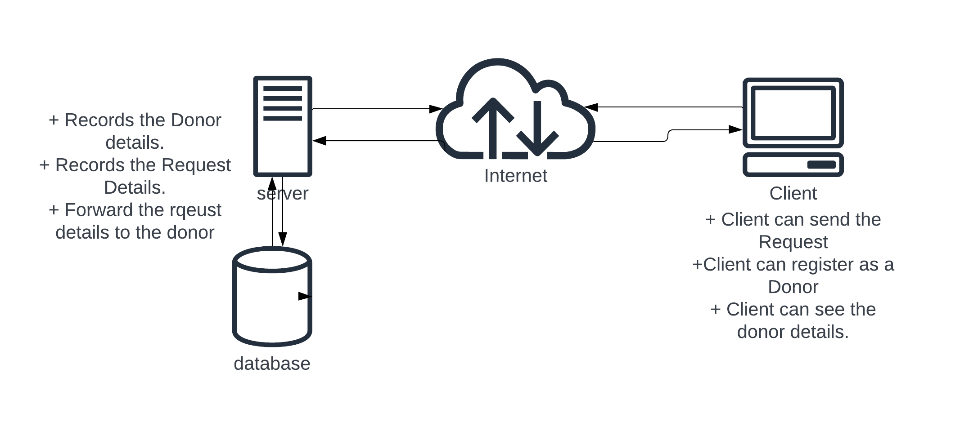

## Figure. 4.1 System Architecture

The Blood Donor Application's system architecture is designed to create a seamless and secure platform connecting blood donors with recipients. The user interface facilitates easy registration for donors and recipients, while a robust authentication system ensures privacy and data security. The database stores and manages user profiles, donation history, and preferences. Real-time notifications and a matching algorithm connect donors with urgent recipient needs based on factors like blood type and location. The geolocation services track donor availability, and a feedback system enhances accountability and recognizes donor contributions. An admin dashboard oversees system management and analytics, and external integrations validate urgent requests. Overall, the architecture prioritizes user experience, security, and efficient coordination to foster a responsive and supportive blood donation community.

## Data Flow Diagram Level 0

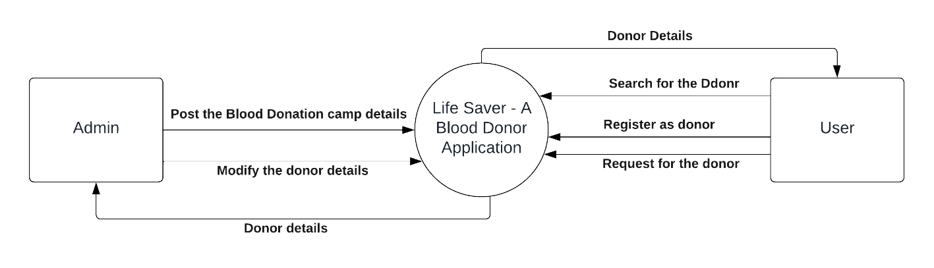

**Figure. 4**.**2 Data Flow Diagram Level 0**

## Data Flow Diagram Level 1

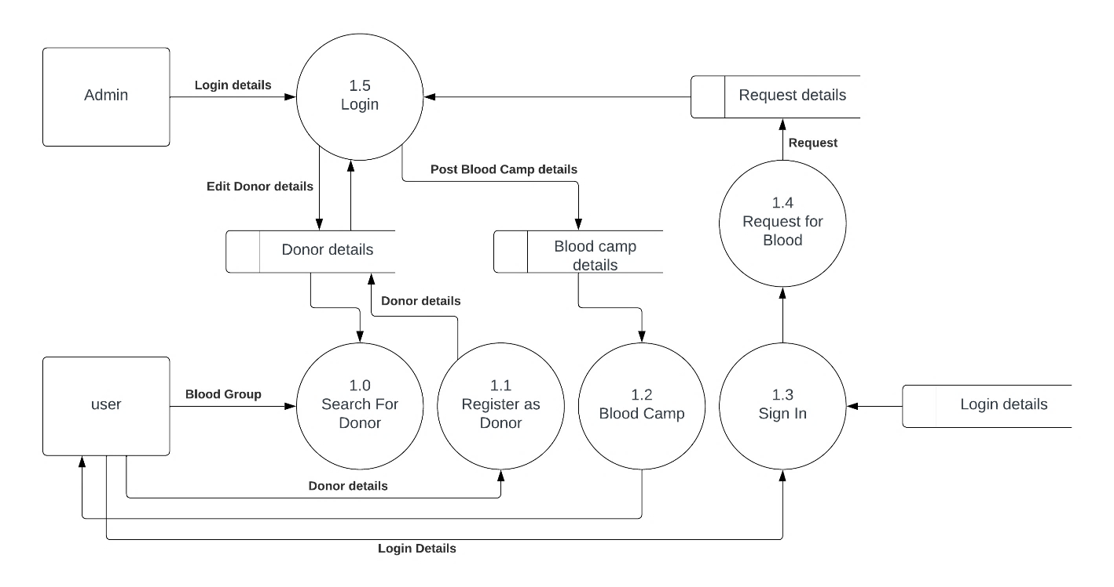

**Figure. 4**.**3 Data Flow Diagram Level 1**

# MODULE DESCRIPTION

Our project consists of the following modules:

* Module 1: Admin Control
* Module 2: Donor Registration
* Module 3: Donor information
* Module 4: Request for the Donor

## MODULE 1: Admin Control

* In the Admin Panel, Admin able to add the user, delete the already existing users.
* Also, admin able to post the Details of Blood Camp.

## MODULE 2: Donor Registration

## In this section, user able to register as a donor for themselves.

## By Register as a donor, details will store in the Donor details table in the database and the Donor will get the notification through the Email what they provide while the registration.

## MODULE 3: Donor Information

* In this section, people can get the Donor details like Name, Phone Number, Blood Group, and City.
* By this details People those who are needed a blood can able to arrange blood easily.
* Details are fetched from the Donor Details table in database.

## MODULE 4: Request For Donor

* By raise the request for blood in this application, the details will be forwarded to the donor those who are registered in the Application through the Email.
* And the Request details will be stored in Request Details table in database for future reference.

# CHAPTER 5

# SYSTEM TESTING

# 5.1. UNIT TESTING

Testing each component or module of the software project is known as unit testing. To perform unit testing, knowledge of programming is necessary. So only programmers do this kind of tests, not testers. A testing technique using which individual modules are tested to determine if there are any issues by the developer himself. It is concerned with functional correctness of the standalone modules. The main aim is to isolate each unit of the system to identify, analyze and fix the defects.

## Advantage

* + 1. Reduces Defects in the newly developed features or reduces bugs when changing the existing functionality.
    2. Reduces Cost of Testing as defects are captured in very early phase.
    3. Improves design and allows better refactoring of code.
    4. Unit Tests, when integrated with build gives the quality of the build as well.

## Scenario

Each and every module after the development stage is tested by the developer before further implementations or moving on to the next module. If a small feature is implemented also it is tested with possible constraints before proceeding further by adding few other features or any other small constructions to the website and app. If once implemented any feature the testing is done at each and every stage to avoid errors solving after complete module completion which makes error solving difficult or unable to solve situation recode from the

first. The User login credentials is verified with firebase database before login in and redirecting to the respective homepage.

## INTEGRATION TESTING

Integration testing Integration testing is the phase in software testing in which individual software modules are combined and tested as a group. It occurs after unit testing and before validation testing. Integration testing takes as its input modules that have been unit tested, groups them in larger aggregates, applies tests defined in an integration test plan to those aggregates, and delivers as its output the integrated system ready for system testing. The purpose of integration testing is to verify functional, performance, and reliability requirements placed on major design items. Simulated usage of shared data areas and inter-process communication is tested, and individual subsystems are exercised through their input interface. Integration Strategies

* + 1. Big-Bang Integration
    2. Top-Down Integration
    3. Bottom-Up Integration
    4. Hybrid Integration

## Scenario

Home page module is integrated with the register and view compliant feature. The register compliant user can register a compliant, that is stored in firebase database and user can view the register compliant from the firebase database.

## FUNCTIONAL TESTING

Functional Testing is a testing technique that is used to test the features/functionality of the system or Software, should cover all the scenarios including failure paths and boundary cases. Functional testing is a quality assurance (QA) process and a type of black box testing that bases its test cases on the specifications of the software component under test. Functions are tested by feeding them input and examining the output, and internal program structure is rarely considered. Functional testing differs from system testing in that functional testing "verifies a program by checking it against ... design document(s) or specification(s)", while system testing "validate a program by checking it against the published user or system requirements" Functional testing typically involves five steps. The identification of functions that the software is expected to perform.

* + 1. The creation of input data based on the function's specifications.
    2. The determination of output based on the function's specifications.
    3. The execution of the test case
    4. The comparison of actual and expected outputs.

## Scenario

In the functional testing, the function implemented is testing before delivering it to the client or hosting as a website online. In the proposed system, Login module is developed and designed with two different logins admin and employee learner login of the Serf Training Portal. Before login of Admin or employee learner login credentials are verified by employee learner or admin gives the username, password in form of html in the browser which is displayed to user of the portal in colorful manner the user gives the input at the database backend user credentials already fed for the verification purpose while login. While login button is pressed the credential in the form is verified with backend in the database once verified the output must be it is redirected to another

Webpage which contains dashboard of the employee learner or the admin with the respective features with a task to perform.

## VALIDATION TESTING

The process of evaluating software during the development process or at the end of the development process to determine whether it satisfies specified business requirements. Validation Testing ensures that the product actually meets the client's needs. It can also be defined as to demonstrate that the product fulfils its intended use when deployed on appropriate environment. The assurance that a product, service, or system meets the needs of the customer and other identified stakeholders. It often involves acceptance and suitability with external customers. Contrast with verification. Validation testing can be best demonstrated using V- Model.

Activities

* + 1. Unit Testing
    2. Integration Testing
    3. System Testing
    4. User Acceptance Testing

## Scenario

In the proposed system, validation testing can be done by making the system available for the 2nd person to use and find errors in the developed system and compare it with the existing system for features and make a testing with a learner to use the portal with all features like register, view compliant and ask the feedback on the developed product. The proposed system is tested with learner other than developers the learner used all features and compared with existing system and gave feedback on the proposed system for further proceedings to add

upon the feature to the portal. On comparison the proposed system meets industry standards and satisfies the needs for which it is developed.

## SYSTEM TESTING

System Testing (ST) is a black box testing technique performed to evaluate the complete system the system's compliance against specified requirements. In System testing, the functionalities of the system are tested from and end-to-end perspective. System Testing is usually carried out by a team that is independent of the development team in order to measure the quality of the system unbiased. It includes both functional and Non-Functional testing. System testing is performed on the entire systemin the context of a Functional Requirement Specification(s) (FRS) and/or a System Requirement Specification (SRS). System testing tests not only the design, but also the behavior and even the believed expectations of the customer.

It is also intended to test up to and beyond the bounds defined in the software/hardware requirements specification.

Types of System Testing

* + 1. Functionality
    2. Stress
    3. Reliability
    4. Regression
    5. Regulatory & Compliance
    6. Performance

## Scenario

After completion of the proposed system, it is tested multiple times on various constraints by the developer and 2nd person. The 2nd person can be either the tester of different module or even client of the proposed system. The current proposed system is tested by the tester of the team and different team of the same department and client of the proposed system with demo for any errors or any kind of feature upgrading from end-to-end perspective. The proposed system is tested functionally and non-functionally. Non-functionality testing is server loading and multiple client access though it is a local server partial Non functionality testing is only possible.

# CHAPTER 6

**RESULT AND DISCUSSION**

* Applications can provide users with easy access to information about blood donation, which can increase their awareness of the need for blood and the benefits of donating.
* Applications can make it easier for people to register to donate blood and schedule appointments. This can lead to an increase in the number of new blood donors.
* Applications can help donors stay connected to the blood donation process by providing them with reminders about upcoming appointments and information about blood donation events. This can help to improve donor retention rates.
* Applications can streamline the blood donation process by making it easier for donors to find information, register, and schedule appointments. This can save time for both donors and blood banks.
* Blood donor applications are a promising tool for increasing blood donations. However, there are a number of challenges that need to be addressed in order to fully realize their potential. These challenges include:
* **Ensuring that the information provided by the applications is accurate and up to date. Protecting the privacy of donor data. Making blood donor applications accessible to a wide range of users.**

# CHAPTER 7

**CONCLUSION**

# CONCLUSION

Blood donor applications have emerged as a valuable tool in the fight against blood shortages, offering a convenient and accessible platform for individuals to learn about, register for, and manage their blood donation journeys. These applications have demonstrated their effectiveness in increasing donor awareness, recruitment, and retention, streamlining the donation process, and ultimately boosting blood supply. However, despite their promising potential, blood donor applications face challenges related to data accuracy, privacy concerns, accessibility limitations, and the potential for overreliance on technology. To fully harness the benefits of these applications, it is crucial to address these challenges by implementing robust data verification and security measures, ensuring wide accessibility, promoting a balanced approach between technology and traditional outreach methods, and fostering continuous collaboration among stakeholders. In conclusion, blood donor applications hold immense potential to revolutionize blood donation practices and enhance the lives of patients in need. By addressing the existing challenges and embracing continuous improvement, these applications can play a pivotal role in bridging the gap between blood supply and demand, saving countless lives in the process.

# 7.2 FUTURE ENHANCEMENT

* **Personalized recommendations:**

Suggest donation schedules based on individual blood types, medical histories, and donor preferences.

* **Real-time blood inventory tracking:**

Provide real-time updates on blood needs and donation center availability.

* **Gamified donation experience:**

Integrate gamification elements to motivate donors and increase engagement.

* **AI-assisted donor screening:**

Utilize AI to streamline eligibility assessments and reduce errors.

* **Targeted outreach campaigns:**

Identify potential donors based on demographics, location, and lifestyle factors.

# APPENDIX

**APPENDIX 1 SOURCE CODE**

# base.html

{% load static %}

<!doctype html>

<html lang="en">

  <head>

    <meta charset="utf-8">

    <meta name="viewport" content="width=device-width, initial-scale=1">

    <!-- Bootstrap CSS -->

    <link href="{% static 'Bootstrap/css/bootstrap.min.css' %}" rel="stylesheet" >

    <title>Life Saver - Blood Donor Application</title>

    <link rel="stylesheet" href="{% static 'css/style.css' %}">

    <!-- AOS -->

    <link href="https://unpkg.com/aos@2.3.1/dist/aos.css" rel="stylesheet">

    <link rel="icon" href="{% static 'images/blood-icon.png'%}">

  </head>

  <body>

    <main>

      <div class="preloader"></div>

      {% block header%}

      {% endblock header%}

      {% block homeSection %}

      {% endblock homeSection %}

      {% block serviceSection %}

      {% endblock serviceSection %}

      {% block contactSection %}

      {% endblock contactSection %}

    </main>

    <script src="{% static 'Bootstrap/js/jquery.js' %}"></script>

    <script src="{% static 'Bootstrap/js/jquery.min.js' %}"></script>

    <script src="{% static 'Bootstrap/js/bootstrap.min.js' %}"></script>

    <script src="https://unpkg.com/aos@2.3.1/dist/aos.js"></script>

    <script>

      // initialization for loader

      let loader = document.querySelector(".preloader");

      window.addEventListener("load", () => {

          loader.style.display = "none";

      })

       // initialization of aos

        AOS.init({

         duration: 800,

        });

      {% comment %} var message_del = document.getElementByClass("alert");

      setTimout(function(){

        message_del.style.display = "none"

      }, 5000) {% endcomment %}

    </script>

  </body>

</html>

# index.html

<!-- navigation bar -->

<nav class="navbar navbar-expand-lg fixed-top py-2" data-aos="fade-down">

  <div class="container">

      <div class="nav-right">

          <a class="navbar-brand heading text-light" href="#">Life Saver</a>

      </div>

      <button class="navbar-toggler" type="button" data-toggle="collapse" data-target="#navbarNav" aria-controls="navbarNav" aria-expanded="false" aria-label="Toggle navigation">

          <svg xmlns="http://www.w3.org/2000/svg" width="40" height="40" fill="currentColor" class="bi bi-list text-light" viewBox="0 0 16 16">

              <path fill-rule="evenodd" d="M2.5 12a.5.5 0 0 1 .5-.5h10a.5.5 0 0 1 0 1H3a.5.5 0 0 1-.5-.5zm0-4a.5.5 0 0 1 .5-.5h10a.5.5 0 0 1 0 1H3a.5.5 0 0 1-.5-.5zm0-4a.5.5 0 0 1 .5-.5h10a.5.5 0 0 1 0 1H3a.5.5 0 0 1-.5-.5z"/>

            </svg>

      </button>

      <div class="collapse navbar-collapse" id="navbarNav">

        <ul class="navbar-nav ml-auto">

          <li class="nav-item">

            <a class="nav-link body text-light" href="#home">Home</span></a>

          </li>

          <li class="nav-item">

            <a class="nav-link body text-light" href="#service">Services</a>

          </li>

          <li class="nav-item">

            <a class="nav-link body text-light" href="#contact">Contact</a>

          </li>

        </ul>

      </div>

  </div>

</nav>

{% endblock header %}

{% block homeSection %}

  <section id="home">

    <div class="container">

      <div class="row"  data-aos="zoom-in-up">

        <marquee behavior="" direction="">

          <p>Life Saver is just an intermediate between the Donors and the People who needs a blood</p>

        </marquee>

          <div class="col-lg-6 col-md-6 col-12">

            <img src="{% static 'images/home-img.png' %}" alt="A sample image for home page" class="img-fluid">

          </div>

          <div class="col-lg-6 col-md-6 col-12 text-center d-flex flex-column justify-content-center align-items-center">

            <h2 class="heading text-center py-lg-0 py-md-0 py-2">

              Your Were Born With The Ability to Change Someone's Life through Donating your Blood.

            </h2>

            <a class="btn" href="#service">Get Started</a>

          </div>

      </div>

    </div>

    <img src="{% static 'images/wave.png' %}" alt="bottom-wave" class="wave img-fluid">

  </section>

{% endblock homeSection %}

{% block serviceSection %}

<section id="service">

  <div class="container">

    <div class="row">

      <div class="col-lg-4 col-md-6 col-12 my-lg-0 my-md-0 my-2" data-aos="fade-right">

        <div class="card h-100 rounded">

          <div class="card-header sub-title text-center" style="background: linear-gradient(45deg, #FF406D, #FF233C);color:#F8F0F9;font-weight:bold;letter-spacing:0.15rem">Send a Request</div>

          <div class="card-body">

            <p class="card-text">By Sending a Blood Request here. We Send your request details to the donor who all are registered in our website. To help you to get the blood.</p>

            <button class="btn btn-link"><a href="{% url 'Request' %}">Go to Request page</a></button>

          </div>

        </div>

      </div>

      <div class="col-lg-4 col-md-6 col-12 my-lg-0 my-md-0 my-2" data-aos="fade-up">

        <div class="card h-100">

          <div class="card-header sub-title text-center" style="background: linear-gradient(45deg, #FF406D, #FF233C);color:#F8F0F9;font-weight:bold;letter-spacing:0.15rem">Search For Donor</div>

          <div class="card-body">

            <p class="card-text">You can also see the donor details to get the Blood by directly contact Donor by using the below link.</p>

            <button class="btn btn-link"><a href="{% url 'Search'%}">See Donor Details</a></button>

          </div>

        </div>

      </div>

      <div class="col-lg-4 col-md-6 col-12 my-lg-0 my-md-2 my-2" data-aos="fade-right">

        <div class="card h-100">

          <div class="card-header sub-title text-center" style="background: linear-gradient(45deg, #FF406D, #FF233C);color:#F8F0F9;font-weight:bold;letter-spacing:0.15rem">Register as Donor</div>

          <div class="card-body">

            <p class="card-text">If you want to save someone's life by donating your blood you can register here. If you registered in our website as a donor you will get a notification through mail whenever a persons request a blood in this website.</p>

            <button class="btn btn-link"><a href="{% url 'Register'%}">Go to Registration</a></button>

          </div>

        </div>

      </div>

    </div>

  </div>

</section>

<section class="bloodCamp">

  <div class="container">

    <h2 class="header">Blood Camp Details</h2>

    <div class="row">

      {% if length %}

      <div class="container">

        <p class="text-center details">No Details Available Now</p>

      </div>

      {% endif%}

      {% for data in details %}

      <div class="col-lg-4 col-md-6 col-12 my-lg-0 my-md-0 my-2" data-aos="fade-right">

        <div class="card h-100">

          <div class="card-body">

            <p class="details">Organiser Name:</p>

            <p>{{data.OrganiserName}}</p>

            <p class="details">Contact Number:</p>

            <p>{{data.ContactNumber}}</p>

            <p class="details">Date: {{data.Date}}</p>

            <p class="details">Time: {{data.Time}}</p>

            <p class="details">Place:</p>

            <p>{{data.Venue}}</p>

          </div>

        </div>

      </div>

      {% endfor %}

    </div>

    <marquee behavior="" direction="">

      <p>If you want to Post the Blood Camp details, Please Send the Details to the Gmail ID: blood.donor.application.gmail.com</p>

    </marquee>

  </div>

</section>

{% endblock serviceSection %}

{% block contactSection %}

<!-- Contact section -->

<section id="contact" class="container">

  <div class="contact-continer row" data-aos="zoom-in">

      <div class="col-lg-6 col-md-6 col-12 con-right">

          <img src="{% static 'images/contact-img.png' %}" alt="Image for Contact" class="img-fluid">

      </div>

      <div class="col-lg-6 col-md-6 col-12 con-left">

          <h2 class="title">Have any Queries?<br><span>Contact us!</span></h2>

          <form action="" method="post" autocomplete="off">

            {% csrf_token %}

              <table>

                  <tbody>

                      <tr>

                          <td>

                              <label for="name" class="details">Full Name</label>

                              <input type="text" name="name" id="name" placeholder="Enter your Name" required>

                          </td>

                      </tr>

                      <tr>

                          <td>

                              <label for="email" class="details">Email</label><br>

                              <input type="email" name="email" id="email" placeholder="Enter your Email Id" required>

                          </td>

                      </tr>

                      <tr>

                          <td>

                              <label for="subject" class="details">Subject</label><br>

                              <input type="text" name="subject" id="subject" required>

                          </td>

                      </tr>

                      <tr>

                          <td>

                              <label for="message" class="details">Message</label><br>

                              <textarea name="message" id="message"></textarea>

                          </td>

                      </tr>

                      <tr>

                          <td>

                            <button>

                              <div class="svg-wrapper-1">

                                <div class="svg-wrapper">

                                  <svg height="24" width="24" viewBox="0 0 24 24" xmlns="http://www.w3.org/2000/svg">

                                    <path d="M0 0h24v24H0z" fill="none"></path>

                                    <path d="M1.946 9.315c-.522-.174-.527-.455.01-.634l19.087-6.362c.529-.176.832.12.684.638l-5.454 19.086c-.15.529-.455.547-.679.045L12 14l6-8-8 6-8.054-2.685z" fill="currentColor"></path>

                                  </svg>

                                </div>

                              </div>

                              <span>Send</span>

                            </button>

                          </td>

                      </tr>

                  </tbody>

              </table>

          </form>

      </div>

  </div>

</section>

{% endblock contactSection %}

# login.html

{% load static %}

<!DOCTYPE html>

<html lang="en">

<head>

    <meta charset="UTF-8">

    <meta name="viewport" content="width=device-width, initial-scale=1.0">

    <title>Login Page - Life Saver</title>

    <link rel="icon" href="{% static 'images/blood-icon.png' %}">

    <link rel="stylesheet" href="{% static 'Bootstrap/css/bootstrap.min.css' %}">

    <link rel="stylesheet" href="{% static 'css/login.css' %}">

</head>

<body>

    <nav class="navbar navbar-expand-lg fixed-top py-2">

        <div class="container">

            <div class="nav-right">

                <a class="navbar-brand heading text-light" href="#">Life Saver</a>

            </div>

            <div id="navbarNav">

                <ul class="navbar-nav ml-auto">

                    <li class="nav-item">

                        <a class="nav-link body text-light" href="{%url 'Home'%}">

                            <svg xmlns="http://www.w3.org/2000/svg" width="48" height="48" fill="currentColor"

                                class="bi bi-skip-backward-fill" viewBox="0 0 16 16">

                                <path

                                    d="M.5 3.5A.5.5 0 0 0 0 4v8a.5.5 0 0 0 1 0V8.753l6.267 3.636c.54.313 1.233-.066 1.233-.697v-2.94l6.267 3.636c.54.314 1.233-.065 1.233-.696V4.308c0-.63-.693-1.01-1.233-.696L8.5 7.248v-2.94c0-.63-.692-1.01-1.233-.696L1 7.248V4a.5.5 0 0 0-.5-.5z" />

                            </svg></a>

                    </li>

                </ul>

            </div>

        </div>

    </nav>

    <div class="container loginContainer">

        <div class="row">

            <div class="col col-12">

                <h2 class="heading">LOGIN HERE</h2>

                <form action="" class="d-flex flex-column" method="post" autocomplete="off">

                    {% csrf_token %}

                    {% if messages %}

                        {% for message in messages %}

                            <div class="alert alert-{{message.tags}}">

                                {{message}}

                            </div>

                        {% endfor %}

                    {% endif %}

                    <fieldset class="UsernameGroup">

                        <label for="name" class="login_details">Username</label><br>

                        <input type="text" name="name" id="name" placeholder="Enter your UserName" class="input"

                            required>

                    </fieldset>

                    <fieldset class="passwordGroup">

                        <label for="password" class="password">Password</label><br>

                        <input type="password" name="password" id="password" placeholder="Enter your Password"

                            class="input" required>

                    </fieldset>

                    <p class="forgot-password-link"><a href="{% url 'ForgetPassword' %}">Forgot your password?</a></p>

                    <div class="btn-container text-center">

                        <!-- <button class="btn btn-success" type="login">

                            <span class="btn-text-one"><a href="{% url 'BloodRequest' %}"></a>Log In</span>

                             <span class="btn-text-two">Registered</span> -->

                        <!-- </button> -->

                        <button type="submit"><a class="btn btn-success">Login</a></button>

                    </div>

                </form>

                <p class="signup text-center details">Don't have an Account?

                    <a href="{% url 'Signup' %}">Signup</a>

                </p>

            </div>

        </div>

    </div>

</body>

</html>

# register.html

{% load static %}

<!DOCTYPE html>

<html lang="en">

<head>

    <meta charset="UTF-8">

    <meta name="viewport" content="width=device-width, initial-scale=1.0">

    <title>Life Saver - Registration Page</title>

    <link href="{% static 'Bootstrap/css/bootstrap.min.css' %}" rel="stylesheet">

    <link rel="icon" href="{% static 'images/blood-icon.png'%}">

    <link rel="stylesheet" href="{% static 'css/register.css' %}">

</head>

<body>

    <div class="preloader"></div>

    <!-- navigation bar -->

    <nav class="navbar navbar-expand-lg fixed-top py-2">

        <div class="container">

            <div class="nav-right">

                <a class="navbar-brand heading text-light" href="#">Life Saver</a>

            </div>

            <div id="navbarNav">

                <ul class="navbar-nav ml-auto">

                    <li class="nav-item">

                        <a class="nav-link body text-light" href="{%url 'Home'%}">

                            <svg xmlns="http://www.w3.org/2000/svg" width="48" height="48" fill="currentColor"

                                class="bi bi-skip-backward-fill" viewBox="0 0 16 16">

                                <path

                                    d="M.5 3.5A.5.5 0 0 0 0 4v8a.5.5 0 0 0 1 0V8.753l6.267 3.636c.54.313 1.233-.066 1.233-.697v-2.94l6.267 3.636c.54.314 1.233-.065 1.233-.696V4.308c0-.63-.693-1.01-1.233-.696L8.5 7.248v-2.94c0-.63-.692-1.01-1.233-.696L1 7.248V4a.5.5 0 0 0-.5-.5z" />

                            </svg></a>

                    </li>

                </ul>

            </div>

        </div>

    </nav>

    <!-- Login container -->

    <section class="container login">

        <div class="row">

            <div class="col col-12">

                <h2 class="title text-center text-light">Donor Registration</h2>

                <img src="{% static 'images/login-img.png' %}" alt="Image for login page" class="img-fluid">

                <form action="" class="d-flex flex-column" method="post">

                    {% csrf_token %}

                    {% if messages %}

                        {% for message in messages %}

                            <div class="alert alert-{{message.tags}}">

                                {{message}}

                            </div>

                        {% endfor %}

                    {% endif %}

                    <fieldset class="nameGroup">

                        <label for="name" class="details">Full Name <span>*</span></label><br>

                        <input type="text" name="name" id="name" placeholder="Enter your Full Name" class="input" required>

                    </fieldset>

                    <fieldset class="emailGroup">

                        <label for="email" class="details">Email <span>*</span></label><br>

                        <input type="email" name="email" id="email" placeholder="Enter your Email Id"

                            class="input" required>

                    </fieldset>

                    <fieldset class="genderGroup">

                        <label for="gender" class="details">Gender <span>*</span></label><br>

                        <span id="gender">

                            <input type="radio" name="gender" id="male" value="male" checked>

                            <label for="male" class="details">Male</label>

                            <input type="radio" name="gender" id="female" value="female">

                            <label for="female" class="details">Female</label>

                            <input type="radio" name="gender" id="others" value="others">

                            <label for="others" class="details">Others</label>

                        </span>

                    </fieldset>

                    <fieldset class="bloodGroupm text-left">

                        <label for="bldGroup" class="details">Blood Group <span>*</span></label><br>

                        <select name="bldgroup" id="bldGroup" class="input" >

                            <option value="">Select Blood Group</option>

                            <option value="A+">A+</option>

                            <option value="B+">B+</option>

                            <option value="O+">O+</option>

                            <option value="AB+">AB+</option>

                            <option value="A-">A-</option>

                            <option value="B-">B-</option>

                            <option value="O-">O-</option>

                            <option value="AB-">AB-</option>

                        </select>

                    </fieldset>

                    <fieldset>

                        <label for="dob" class="details">Date of Birth <span>*</span></label><br>

                        <input type="date" name="dob" id="dob" class="input" required>

                    </fieldset>

                    <fieldset class="stateGroup">

                        <label for="state" class="details">State <span>*</span></label><br>

                        <select name="state" id="state" class="input" onchange="loadDistrict()">

                            <option value="">Select State</option>

                        </select>

                    </fieldset>

                    <fieldset class="disGroup">

                        <label for="inputDistrict" class="details">City <span>*</span></label><br>

                        <select name="city" id="inputDistrict" class="input">

                            <option value="">Select City</option>

                        </select>

                    </fieldset>

                    <fieldset class="addressGrp">

                        <label for="address" class="details">Address <span>*</span></label><br>

                        <textarea name="address" id="address" cols="35" rows="4" required></textarea>

                    </fieldset>

                    <fieldset class="phGroup">

                        <label for="phNo" class="details">Contact Number <span>*</span></label><br>

                        <input type="text" id="phNo" name="phNo" placeholder="Enter your Contact Number" required

                            class="input">

                    </fieldset>

                    {% comment %} <fieldset>

                        <label for="">Choose Your photo <span>*</span></label>

                        <input type="file" name="photo" id="photo">

                    </fieldset> {% endcomment %}

                    <fieldset class="termsGroup">

                        <input type="checkbox" name="terms" id="terms" required>

                        <label for="terms" class="details my-3">I Accept to be a Volutary Donor</label>

                    </fieldset>

                    <button class="btn" type="submit">

                        <span class="btn-text-one">Register</span>

                        <!-- <span class="btn-text-two">Registered</span> -->

                    </button>

                </form>

            </div>

        </div>

    </section>

    <script src="{% static 'Bootstrap/js/jquery.js' %}"></script>

    <script src="{% static 'Bootstrap/js/bootstrap.min.js' %}"></script>

    <script>

        // initialization for loader

        let loader = document.querySelector(".preloader");

        window.addEventListener("load", () => {

            loader.style.display = "none";

        })

    </script>

    <script src="{% static 'js/register.js' %}"></script>

</body>

</html>

* **forget.html**

{% load static %}

<!DOCTYPE html>

<html lang="en">

<head>

    <meta charset="UTF-8">

    <meta name="viewport" content="width=device-width, initial-scale=1.0">

    <title>Forget Password - Life Saver</title>

    <link rel="icon" href="{% static 'images/blood-icon.png' %}">

    <link rel="stylesheet" href="{% static 'Bootstrap/css/bootstrap.min.css' %}">

    <link rel="stylesheet" href="{% static 'css/signup.css' %}">

</head>

<body>

    <div class="preloader"></div>

    <!-- Navigation Bar Start -->

    <nav class="navbar navbar-expand-lg fixed-top py-2">

        <div class="container">

            <div class="nav-right">

                <a class="navbar-brand heading text-light" href="#">Life Saver</a>

            </div>

            <div id="navbarNav">

                <ul class="navbar-nav ml-auto">

                    <li class="nav-item">

                        <a class="nav-link body text-light" href="{%url 'Home'%}">

                            <svg xmlns="http://www.w3.org/2000/svg" width="48" height="48" fill="currentColor"

                                class="bi bi-skip-backward-fill" viewBox="0 0 16 16">

                                <path

                                    d="M.5 3.5A.5.5 0 0 0 0 4v8a.5.5 0 0 0 1 0V8.753l6.267 3.636c.54.313 1.233-.066 1.233-.697v-2.94l6.267 3.636c.54.314 1.233-.065 1.233-.696V4.308c0-.63-.693-1.01-1.233-.696L8.5 7.248v-2.94c0-.63-.692-1.01-1.233-.696L1 7.248V4a.5.5 0 0 0-.5-.5z" />

                            </svg></a>

                    </li>

                </ul>

            </div>

        </div>

    </nav>

    <!-- Navigation End -->

    <div class="container requestContainer">

        <div class="row">

            <div class="col col-12 d-flex d-flex flex-column">

                <h2 class="title text-center">Forget Password?</h2>

                <form action="" method="post">

                    {% csrf_token %}

                    {% if messages %}

                        {% for message in messages %}

                        <div class="alert alert-{{message.tags}} my-2">

                            {{message}}

                        </div>

                        {% endfor %}

                    {% endif %}

                    <fieldset class="UsernameGroup">

                        <label for="name" class="login_details ">Username</label><br>

                        <input type="text" name="name" id="name" placeholder="Enter your UserName" class="input"

                            required>

                    </fieldset>

                    <fieldset class="emailGroup">

                        <label for="email" class="details">Email Id</label><br>

                        <input type="email" name="email" id="email" placeholder="Enter your Email Id" class="input"

                            required>

                    </fieldset>

                    <fieldset class="passwordGroup">

                        <label for="password" class="password">Password</label><br>

                        <input type="password" name="password" id="password" placeholder="Enter your Password"

                            class="input" required>

                    </fieldset>

                    <fieldset class="confirmpasswordGroup">

                        <label for="confirmpassword" class="confirmpassword">Confirm Password</label><br>

                        <input type="password" name="Conpassword" id="Conpassword" placeholder="Re-Type your password"

                            class="input" required>

                    </fieldset>

                    <button class="btn btn-success">

                        <span class="btn-text-one">Change Password</span>

                    </button>

                </form>

        </div>

    </div>

    <script src="{% static 'Bootstrap/js/jquery.js' %}"></script>

    <script src="{% static 'Bootstrap/js/bootstrap.min.js' %}"></script>

    <script>

        // initialization for loader

        let loader = document.querySelector(".preloader");

        window.addEventListener("load", () => {

            loader.style.display = "none";

        })

    </script>

</body>

</html>

* **Request.html**

{% load static %}

<!DOCTYPE html>

<html lang="en">

<head>

    <meta charset="UTF-8">

    <meta name="viewport" content="width=device-width, initial-scale=1.0">

    <title>Blood Request - Life Saver</title>

    <link rel="icon" href="{% static 'images/blood-icon.png' %}">

    <link rel="stylesheet" href="{% static 'Bootstrap/css/bootstrap.min.css' %}">

    <link rel="stylesheet" href="{% static 'css/signup.css' %}">

</head>

<body>

    <div class="preloader"></div>

    <!-- Navigation Bar Start -->

    <nav class="navbar navbar-expand-lg fixed-top py-2">

        <div class="container">

            <div class="nav-right">

                <a class="navbar-brand heading text-light" href="#">Life Saver</a>

            </div>

            <div id="navbarNav">

                <ul class="navbar-nav ml-auto">

                    <li class="nav-item">

                        <a class="nav-link body text-light" href="{%url 'Home'%}">

                            <svg xmlns="http://www.w3.org/2000/svg" width="48" height="48" fill="currentColor"

                                class="bi bi-skip-backward-fill" viewBox="0 0 16 16">

                                <path

                                    d="M.5 3.5A.5.5 0 0 0 0 4v8a.5.5 0 0 0 1 0V8.753l6.267 3.636c.54.313 1.233-.066 1.233-.697v-2.94l6.267 3.636c.54.314 1.233-.065 1.233-.696V4.308c0-.63-.693-1.01-1.233-.696L8.5 7.248v-2.94c0-.63-.692-1.01-1.233-.696L1 7.248V4a.5.5 0 0 0-.5-.5z" />

                            </svg></a>

                    </li>

                </ul>

            </div>

        </div>

    </nav>

    <!-- Navigation End -->

    <div class="container requestContainer">

        <div class="row">

            <div class="col col-12 d-flex flex-column">

                <h2 class="title text-center">Request For Blood</h2>

                <form action="" method="post" autocomplete="off">

                    {% csrf_token %}

                    {% if messages %}

                        {% for message in messages %}

                            <div class="alert alert-{{message.tags}}">

                                {{message}}

                            </div>

                        {% endfor %}

                    {% endif %}

                    <hr>

                    <h4 class="details">Total Donors = {{total}}</h4>

                    <hr>

                    <fieldset class="PatientNameGroup">

                        <label for="name" class="details">Patient Name</label><br>

                        <input type="text" name="name" id="name" placeholder="Enter the Patient Name" class="input"

                            required>

                    </fieldset>

                    <fieldset class="AttenderGroup">

                        <label for="attender" class="details">Attender Contact Number</label><br>

                        <input type="text" name="attender" id="attender" placeholder="Enter The Attender Ph. No." class="input"

                            required>

                    </fieldset>

                    <fieldset class="bldGroup">

                        <label for="bldGroup" class="details">Blood Group</label><br>

                        <select name="bldGroup" id="bldGroup" class="input" >

                            <option value="">Select the blood Group</option>

                            <option value="A+">A+</option>

                            <option value="B+">B+</option>

                            <option value="O+">O+</option>

                            <option value="AB+">AB+</option>

                            <option value="A-">A-</option>

                            <option value="B-">B-</option>

                            <option value="O-">O-</option>

                            <option value="AB-">AB-</option>

                        </select>

                    </fieldset>

                    <fieldset class="unitsGroup">

                        <label for="units" class="details">Units</label><br>

                        <input type="text" name="units" id="units" placeholder="How many Units Needed?"

                            class="input" required>

                    </fieldset>

                    <fieldset class="reasonGroup">

                        <label for="reason" class="details">Reason</label><br>

                        <input type="text" name="reason" id="reason" placeholder="For what reason you need blood"

                            class="input" required>

                    </fieldset>

                    <fieldset class="stateGroup">

                        <label for="city" class="details">State</label><br>

                        <select name="stateGroup" id="stateGroup" class="input" onchange="loadDistrict()">

                            <option value="">Select State</option>

                        </select>

                    </fieldset>

                    <fieldset class="cityGroup">

                        <label for="city" class="details">City</label><br>

                        <select name="cityGroup" id="cityGroup" class="input" >

                            <option value="">Select City</option>

                        </select>

                    </fieldset>

                    <fieldset class="hospitaladdressGrp">

                        <label for="hospitaladdress" class="details">Hospital Details</label><br>

                        <textarea name="address" id="address" cols="35" rows="4" required></textarea>

                    </fieldset>

                    <button class="btn btn-success">

                        <span class="btn-text-one">Request the Blood</span>

                    </button>

                </form>

        </div>

    </div>

    <script src="{% static 'Bootstrap/js/jquery.js' %}"></script>

    <script src="{% static 'Bootstrap/js/bootstrap.min.js' %}"></script>

    <script src="{% static 'js/request.js' %}"></script>

    <script>

        // initialization for loader

        let loader = document.querySelector(".preloader");

        window.addEventListener("load", () => {

            loader.style.display = "none";

        })

    </script>

</body>

</html>

* **Search.html**

{% load static %}

<!DOCTYPE html>

<html lang="en">

<head>

    <meta charset="UTF-8">

    <meta name="viewport" content="width=device-width, initial-scale=1.0">

    <title>Search for a Donor - Life Saver</title>

    <link rel="stylesheet" href="{%static 'Bootstrap/css/bootstrap.min.css' %}">

    <link rel="stylesheet" href="{%static 'css/search.css' %}">

    <link rel="icon" href="{% static 'images/blood-icon.png' %}">

</head>

<body>

    <div class="preloader"></div>

    <!-- navigation bar -->

    <nav class="navbar navbar-expand-lg fixed-top py-2 bg-dark">

        <div class="container">

            <div class="nav-right">

                <a class="navbar-brand heading text-light" href="#">Life Saver</a>

            </div>

            <div id="navbarNav">

                <ul class="navbar-nav ml-auto">

                    <li class="nav-item">

                        <a class="nav-link body text-light" href="{%url 'Home'%}">

                            <svg xmlns="http://www.w3.org/2000/svg" width="48" height="48" fill="currentColor"

                                class="bi bi-skip-backward-fill" viewBox="0 0 16 16">

                                <path

                                    d="M.5 3.5A.5.5 0 0 0 0 4v8a.5.5 0 0 0 1 0V8.753l6.267 3.636c.54.313 1.233-.066 1.233-.697v-2.94l6.267 3.636c.54.314 1.233-.065 1.233-.696V4.308c0-.63-.693-1.01-1.233-.696L8.5 7.248v-2.94c0-.63-.692-1.01-1.233-.696L1 7.248V4a.5.5 0 0 0-.5-.5z" />

                            </svg></a>

                    </li>

                </ul>

            </div>

        </div>

    </nav>

    <!-- Navigation bar end -->

    <!-- Search Panel start -->

    <div class="container searchcontainer py-2">

        <p class="title text-center">Search for a Donor</p>

        <hr>

        <form action="" method="post">

            {% csrf_token %}

            <div class="search-option-container">

                <label for="choice" class="detail">Search By</label><br>

                <fieldset class="bloodGroupm text-left">

                    <label for="bldGroup" class="details">Blood Group <span>:</span></label>

                    <select name="bldgroup" id="bldGroup" class="input" >

                        <option value="">Select Blood Group</option>

                        <option value="A+">A+</option>

                        <option value="B+">B+</option>

                        <option value="O+">O+</option>

                        <option value="AB+">AB+</option>

                        <option value="A-">A-</option>

                        <option value="B-">B-</option>

                        <option value="O-">O-</option>

                        <option value="AB-">AB-</option>

                    </select>

                </fieldset>

                <fieldset class="stateGroup">

                    <label for="state" class="details">State <span>:</span></label>

                    <select name="state" id="state" class="input w-50" onchange="loadDistrict()">

                        <option value="">Select State</option>

                    </select>

                </fieldset>

                <fieldset class="disGroup">

                    <label for="inputDistrict" class="details">City <span>:</span></label>

                    <select name="city" id="inputDistrict" class="input">

                        <option value="">Select City</option>

                    </select>

                </fieldset>

                <button class="btn btn-success">Show</button>

                <a href="{%url 'Search'%}" class="btn btn-success">Show all</a>

            </div>

            {% if messages %}

                        {% for message in messages %}

                        <div class="alert alert-{{message.tags}} my-2">

                            {{message}}

                        </div>

                        {% endfor %}

                    {% endif %}

        </form>

        <hr>

        <div class="table-responsive">

            <caption><h5 class="details">Total Donors = {{total}}</h5></caption>

            <table class="table">

                <tr class="bg-danger text-light">

                    <th>Name</th>

                    <th>Blood Group</th>

                    <th>Phone Number</th>

                    <th>City</th>

                </tr>

                {% for data in instance %}

                <tr>

                    <td>{{data.Fullname}}</td>

                    <td>{{data.BloodGroup}}</td>

                    <td>{{data.Contact}}</td>

                    <td>{{data.District}}</td>

                </tr>

                {% endfor %}

            </table>

        </div>

    </div>

    <!-- Search panel end -->

    <script src="{% static 'Bootstrap/js/jquery.js' %}"></script>

    <script src="{% static 'Bootstrap/js/bootstrap.min.js' %}"></script>

    <script>

        // initialization for loader

        let loader = document.querySelector(".preloader");

        window.addEventListener("load", () => {

            loader.style.display = "none";

        })

    </script>

    <script src="{% static 'js/search.js' %}"></script>

</body>

</html>

**APPENDIX - 2**

**SCREEN SHOTS**

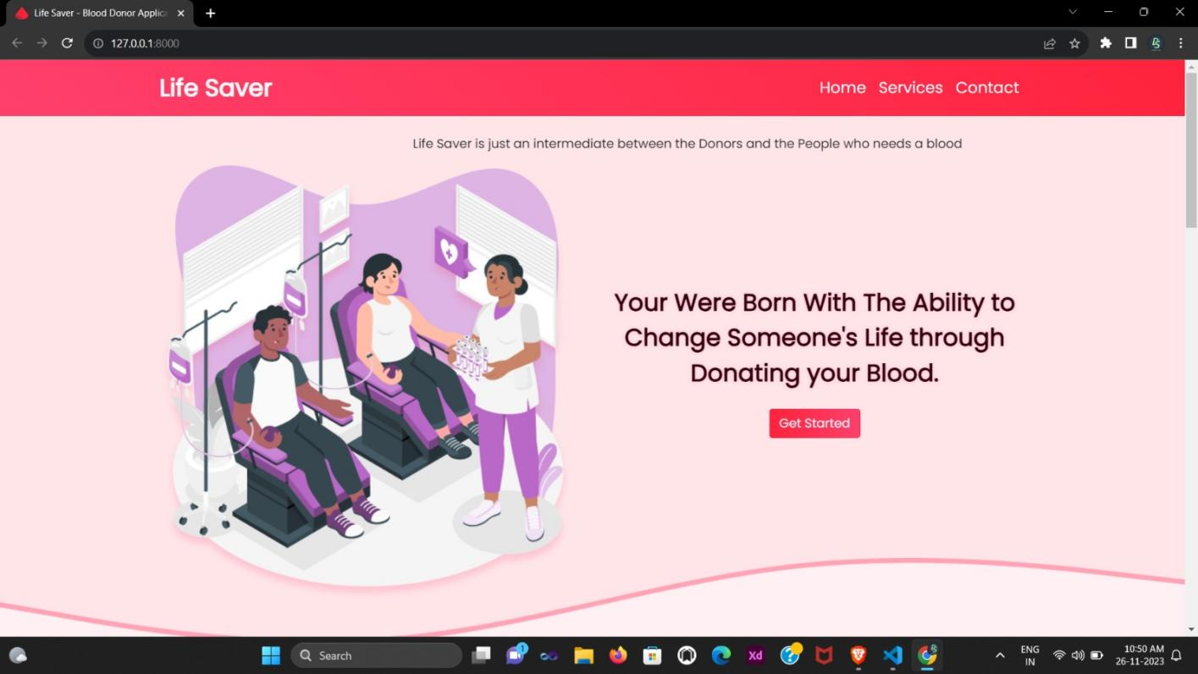

**1.HOME PAGE - 1**

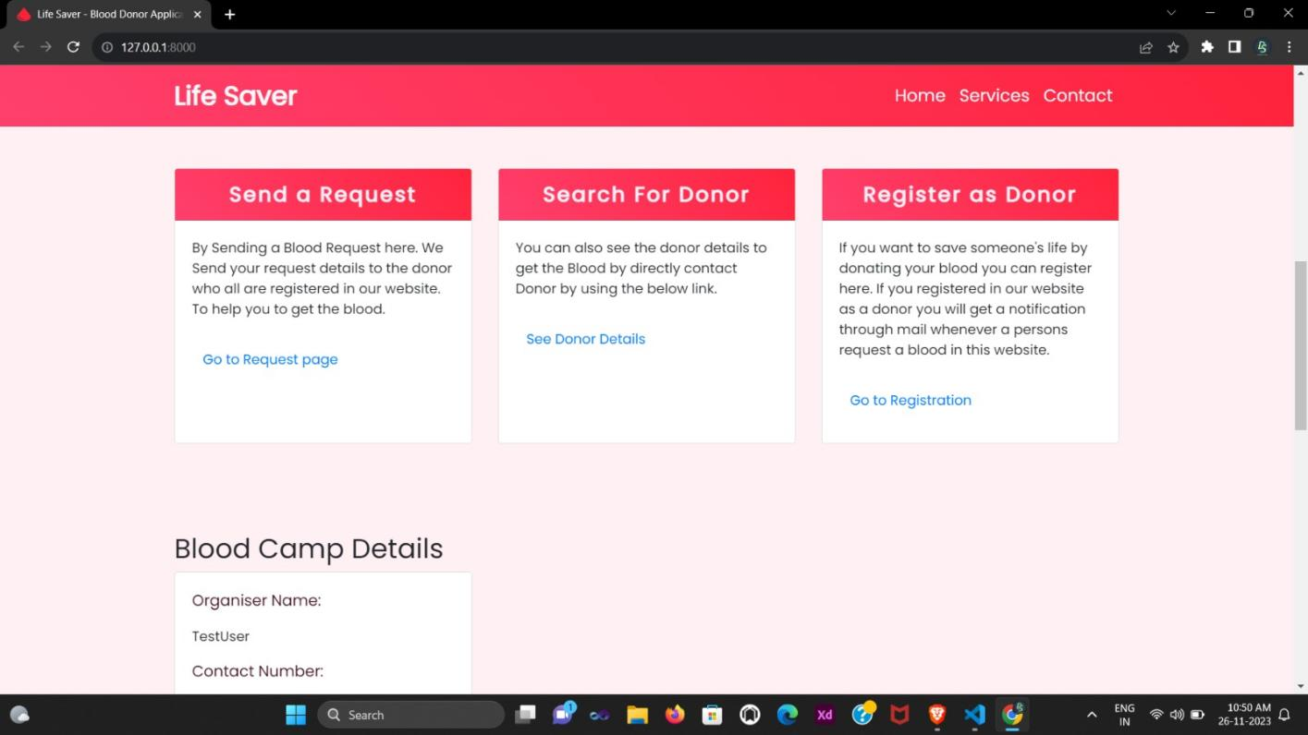

**2.HOME PAGE - 2**

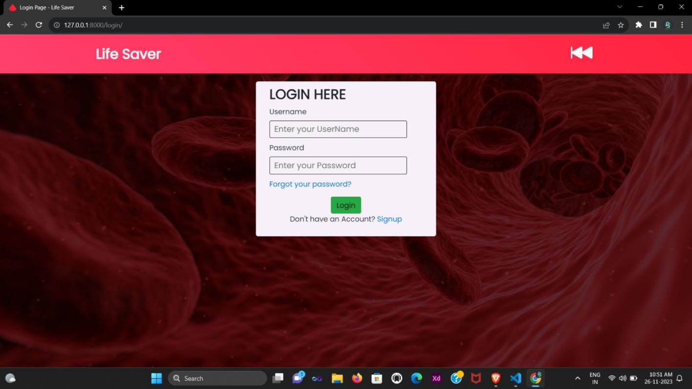

**3.LOGIN PAGE**

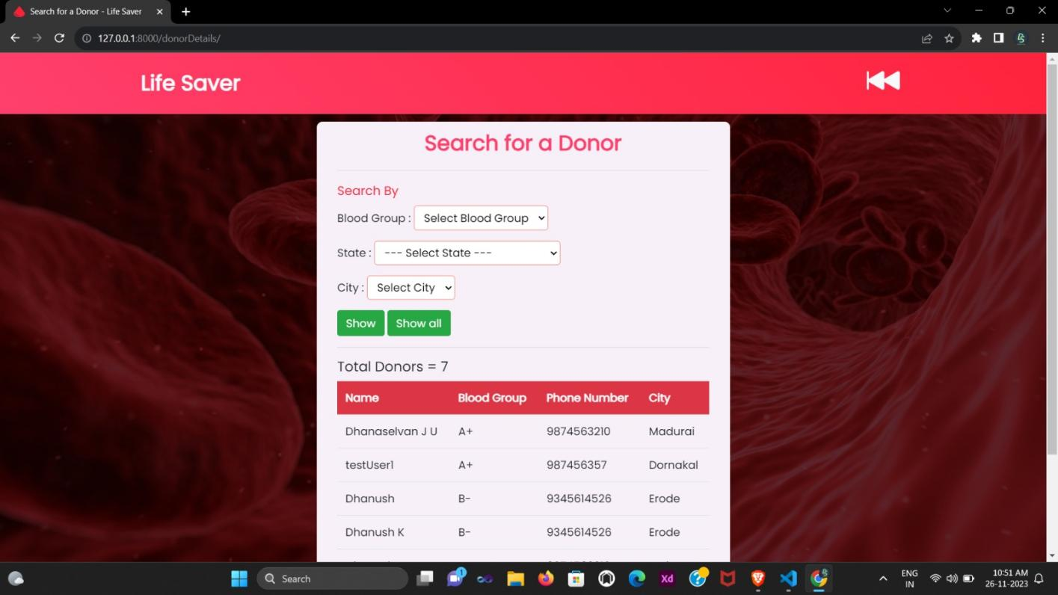

**4.SEARCH PAGE**

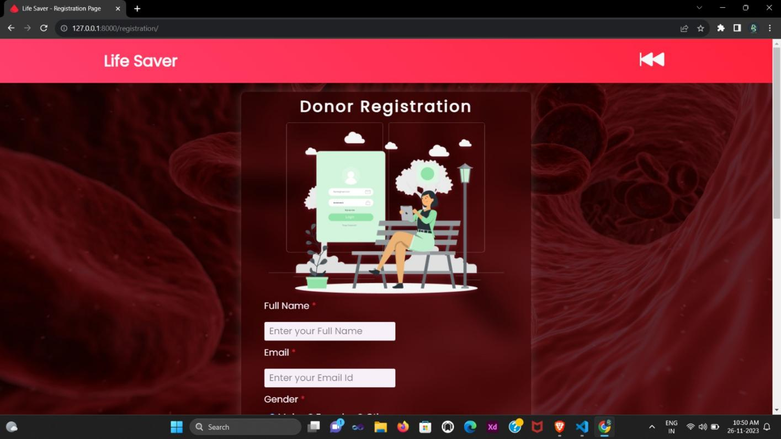

**5.REGISTER PAGE**

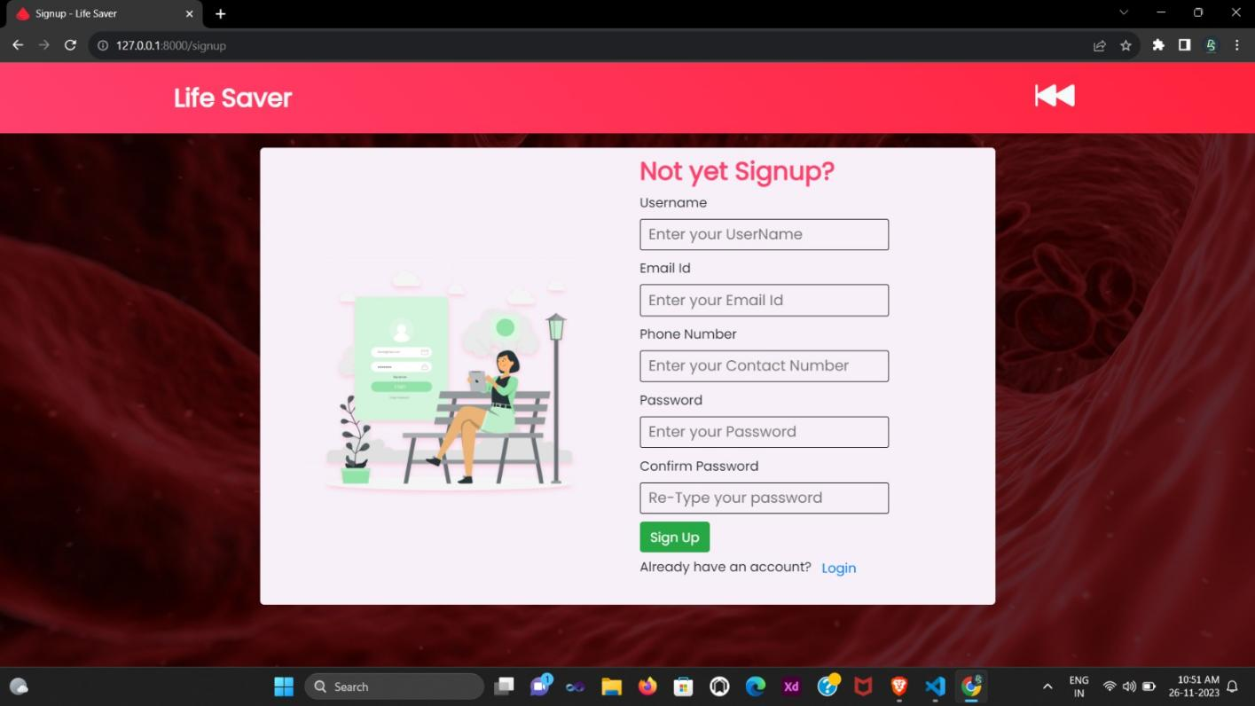

**6.SIGNUP PAGE**

# REFERENCES

**1.** Mohammed Anis Oukebdane, Samir Ghouali, Karima Ghazali and Mohammed Feham, Zomraty: E-Blood Bank Android Application for Donors and Life Savers, Mascara, Algeria:Mustapha Stambouli University, 2020.

2. Rohit S. Remella, Saurav Tomer and Shubham Tomer, A Review Paper on Blood Bank Management System, Uttar Pradesh, India:Department of Computer Science & Engineering ABES Institute of Technology, 2019.

3. Dr. Sharad Maheshwari and Vikas Kulshreshtha, Blood Bank Management Information System in India, Jhalawar:Government Engineering College, 2018.

4. Sultan Turhan, An Android Application for Volunteer Blood Donors, Istanbul, TURKEY:Department of Computer Engineering, Galatasaray University, 2015.

5. Hosam El-Ocla and Vamsi Krishna Tatikonda, BLOODR: blood donor and requester mobile application, Thunder Bay, Canada:Department of Computer Science, Lakehead University, 2017.

6. M.R. Alony and Javed Akhtar Khan, A New Concept of Blood Bank Management System using Cloud Computing for Rural Area (INDIA), Jabalpur (M.P) INDIA:Department of Computer Science & Engineering, Takshshila Institute of Engineering & Technology, 2015.

7. Bhagyashali Munde, Pradnya Randhavan, Rajnandini Patil, Sayali Dhond and Vikas Patil, Android Based Health Application in Cloud Computing For Blood Bank, Pune:Computer Department, SITS, Pune University, 2015.

8. Dana V Devine and Lorna M Williamson, "Challenges in the management of the blood supply", 2013.

9. Christopher D Hillyer and Theresa W Gillespie, "Blood donors and factors impacting the blood donation decision", 2002.

**10.**Balraj Singh, Devanjan K. Srivastava, M.G.Krishna Rao, Priya Manohar and Utkarsh Tanwar, A Research Paper on Blood Donation Management System, Jalandhar, India:School of Computer Science Engineering, Lovely Professional University, 2021.